ID1050A Engineering Design |  | IIT Palakkad

Project Proposal
Proposed Project Idea and Budget for ID1050A

TITLE: Gesture to Speech Gloves for Sign Language

Team Composition  Group-39 | Team Lead: Shourya Shamsher Rana  Members:  - Tarun Padmanabhan  - Sandip Mondal  - Siddamshetty Mani  - Susruti Sristi  - Dhanunjay Nayak

PROJECT OVERVIEW

Objective
The Objective of our project is to build a wearable system of gloves which will capture hand gestures using flex sensors and accelerometer/gyroscopes, and classify them via a predefined sign vocabulary; finally converting them into audible speech output in English and Hindi - thus enabling faster, more natural communication for sign language users interacting with people unaware of the said signs.
Justification
Communication between sign language users and non-signers remains a persistent accessibility gap; the unavailability of human interpreters, most existing assistive translation solutions being too expensive or camera-based systems that require ideal conditions add to this growing gap. We aim to build a low cost glove based system using commercially available flex sensors, which delivers real-time gesture recognition to speech output. To prevent faulty outputs, a Computer Vision based system is used as a failsafe which functions in parallel to the gloves, validating gesture inputs or stepping in when sensor data is ambiguous or faulty.
Beyond its function, this project serves as a practical introduction to embedded systems, sensor interfacing and calibration, and applied machine learning — core skills for the team's engineering coursework.

METHODOLOGY

System Inputs
- Finger flexion data: each of the 10 fingers is equipped with a commercial flex sensor which produces an analog voltage proportional to the changing resistance due to the bending of sensors.
- Hand orientation data: An IMU mounted on the back of the hand distinguishes signs which differ with respect to wrist orientation/ rotation
System Outputs
- Sensor Data translated to text corresponding to respective sign, sent over wifi or bluetooth to the paired laptop/ phone
- Synthesized speech output in English or any other language via a text-to-speech engine.

Signal Pipeline & Mathematical Model
Each flex sensor forms a voltage divider with a fixed resistor R_{e} in series with the sensor's variable resistance R_{s}(θ), where θ is the finger's bend angle. The ADC-read voltage is:
V_{out} = V_{in} × R_{e} / (R_{e} + R_{s}(θ))
For standard flex sensors, R_{s} increases with increasing bend angle θ; so, V_{out} varies monotonically with θ over the sensor's working range. A hardware multiplexer routes the 10 sensor signals into a single ADC channel. The microcontroller cycles through binary addresses 0000 to 1001 to sample each sensor sequentially. This full 10-channel scan completes in milliseconds, ensuring real-time data capture during a static hand gesture.
Each channel's raw ADC reading is normalized using individually calibrated bend values:
x_{i} = (V_{i} − V_{i}(min)) / (V_{i} (max) − V_{i}(min)); i ϵ {1,...,10}
This produces a normalized 10 dimensional vector x = [x₁, ..., x₁₀], alongwith with the IMU readings to form a 10 + n dimensional (n readings from imu) feature vector per time sample. The feature vector is passed to a classification system to identify the corresponding gesture. The initial prototype will use simple conditional logic for said translation. We will consider moving towards machine learning classifiers trained on custom datasets of sign demonstrations as the prototypes succeed in performing. On identification of a sign, the result is mapped to text and passed on to a text-to-speech engine to produce audio output in English or other languages.

WORK PLAN & MILESTONES

# | Task | Members | Wk
1 | Literature Review and Specs | All Members | W1
2 | Component Sourcing / Bench Testing | Shourya | W2
3 | DIY Computer Vision (CV) Integration & Testing | Sandip,Tarun,  Susruti | W3 – W4
4 | ESP32 Signal Processing and Filtering | Shourya,Tarun | W5 – W6
5 | Bluetooth and Phone App Interface | Sandeep, Susruti | W7 – W8
6 | CAD Modeling of Wrist and Guides | Dhanunjay,  Mani | W9
7 | 3D Printing of Enclosure and Prep | Dhanunjay,  Mani | W10
8 | Glove Hardware Assembly | Dhanunjay,  Mani,  Shourya,  Tarun | W11
9 | Gesture and CV Recognition Tuning | All Members | W12
10 | App TTS and Visual Feedback Integration | Tarun,Sandip,Susruti | W13
11 | System Calibration and Testing | All Members | W13
12 | Final Report and Demo | All Members | W14

Charts

PERT
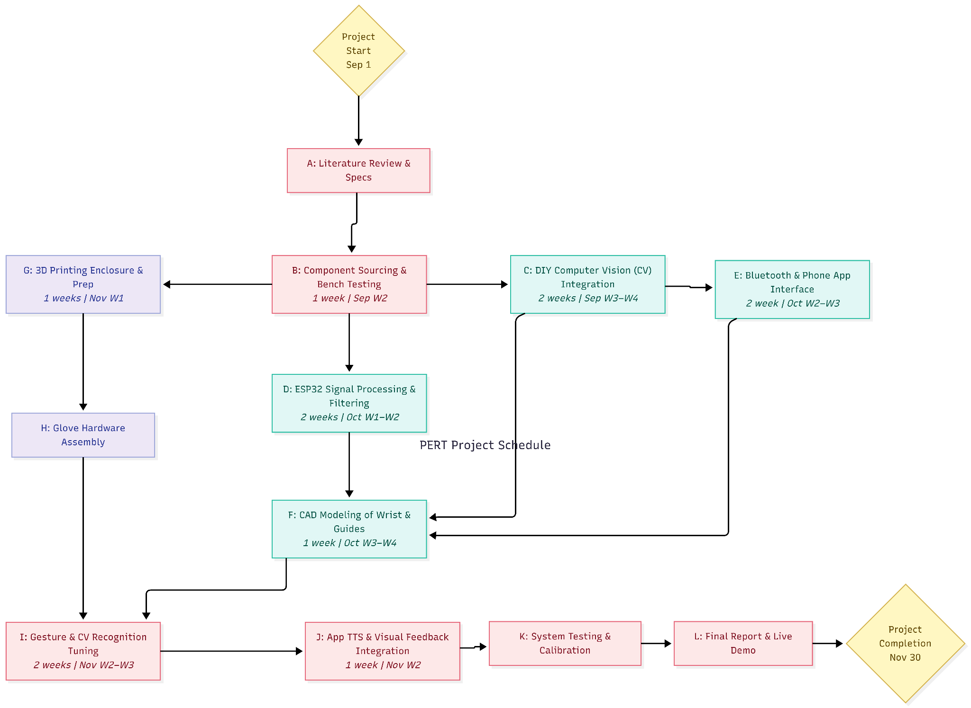

GANTT
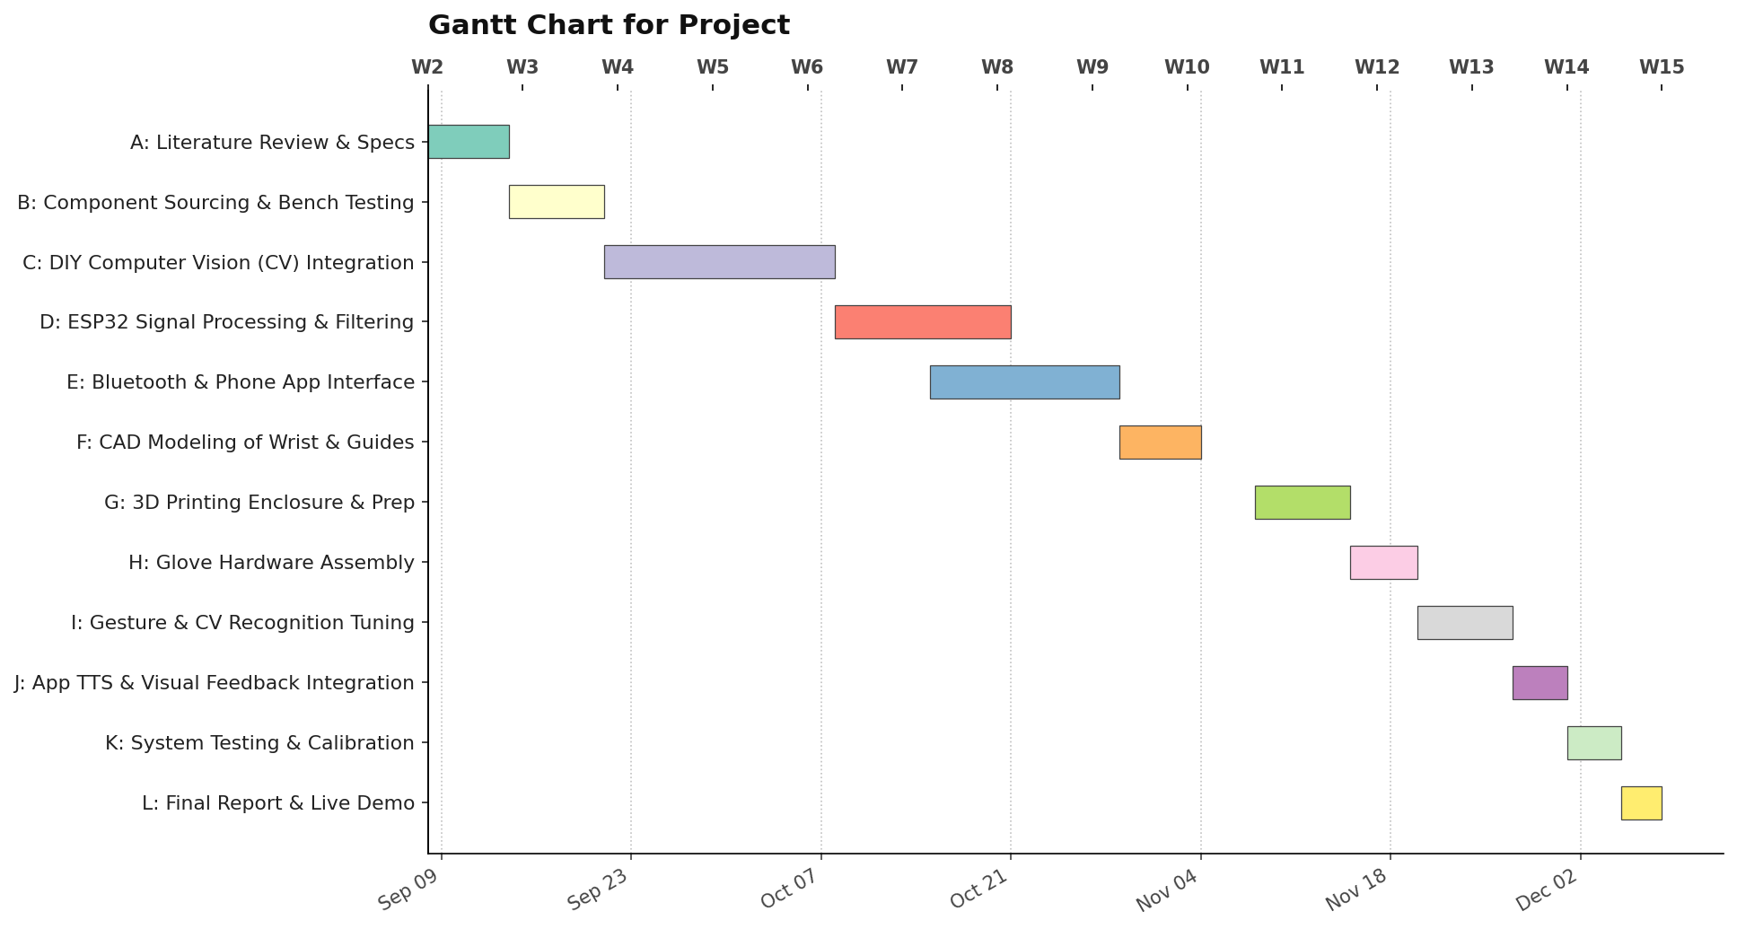

Proposed Budget

# | Item | Qty | Cost per | Total
1 | Resistive flex sensors (4.5") | 10 | 200 | 2000
2 | MPU6050 6-axis IMU module | 2 | 180 | 360
3 | CD74HC4067 16-channel multiplexer | 2 | 120 | 240
4 | ESP32 Microcontroller | 1 | 500 | 500
5 | Gloves & wiring/soldering misc. | 1 | 300 | 300
6 | LiPo Battery + TP4065 Module | 1 | 200 | 200
Estimated Total |  |  |  | ₹3,600

Signature
Team Lead: Shourya Shamsher Rana
04/09/2026

